Ratatouille

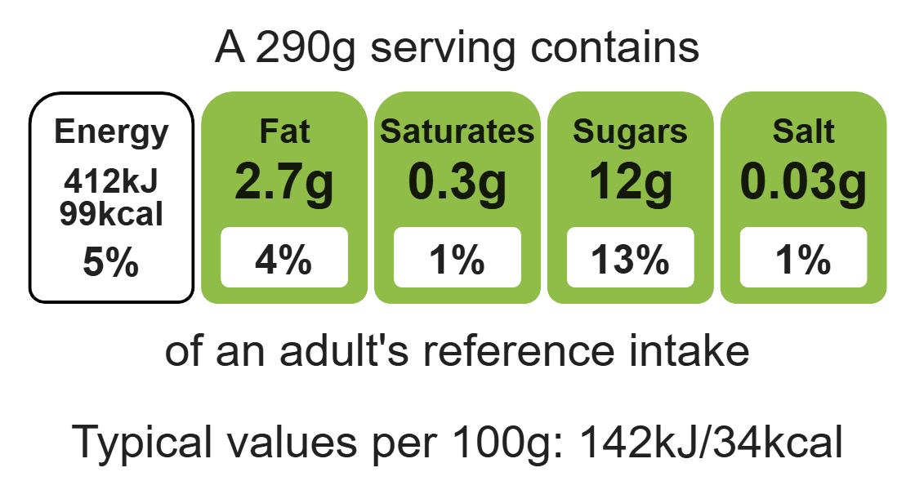
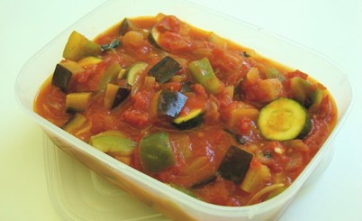

Ingredients (serves 4)

1 onion

1 clove garlic
Complexity: medium

1 aubergine

1 pepper

Equipment

Chopping board

Sharp knife

Garlic press

Saucepan

Measuring spoons

Heat-resistant spoon

Can opener

1 courgette

2 cans chopped tomatoes (800g)

1 x 10ml spoon vegetable oil

1 handful fresh basil

Method
- Preheat the oven to 160ºC or gas mark 4.
- Grease or line the baking tray.
- Sift the flour into the mixing bowl.
- Add the coconut, oats, and sugar into the mixing bowl and mix well.
- Melt the golden syrup and fat together on a low heat in a small saucepan.
- Mix the bicarbonate of soda with the boiling hot water and add to melted syrup and fat immediately.
- Add the wet mixture to the dry ingredients.
- Mix thoroughly until combined.
- Divide the mixture evenly into 8 portions using the metal spoon.
- Use lightly floured hands to shape the biscuits into round balls and place onto the prepared baking tray.
- Slightly flatten the biscuits with a lightly floured fork.
- Bake for 15-20 minutes, until golden brown.
- Cool on the baking tray for a few minutes, to allow the biscuits to firm, before transferring them to a cooling rack.

Top tips
- Turn up the flavour: Use dried herbs if you do not have fresh basil. Try other herbs such as oregano or spices such as chilli or smoke paprika.
- Reduce food waste: Use up any leftover vegetables try adding olives, mushrooms, red onions, peas or beans.
- Serving suggestion: Serve the ratatouille with roasted chicken or grilled fish.

Food skills
Measure, peel, cut, chop, slice, dice and trim, fry and sauté, melt, simmer and boil.

