Washing up

First: Cut out the boxes

Then: Put them in the correct order for washing up

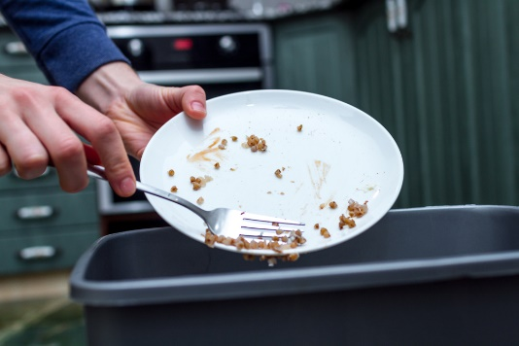 | Scrape left over food into the bin.

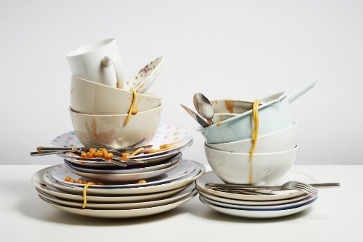 | Stack items by the side of the sink.

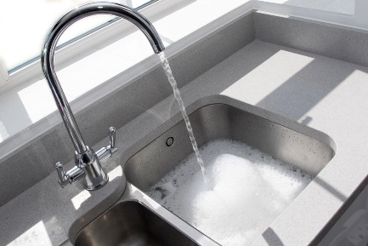 | Fill the sink with warm water and washing up liquid

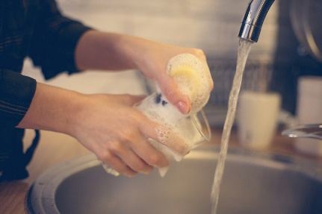 | Wash and rinse the glasses

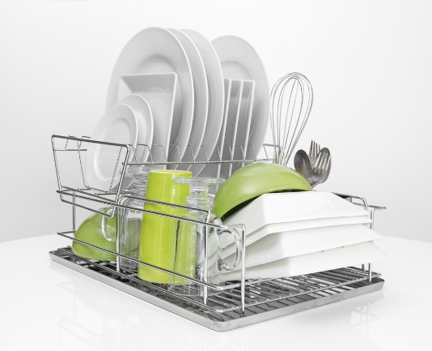 | Place washed items on the draining board ready for drying up

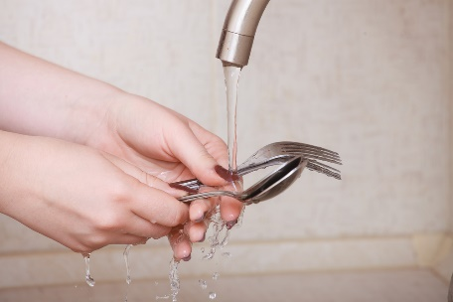 | Wash and rinse the cutlery

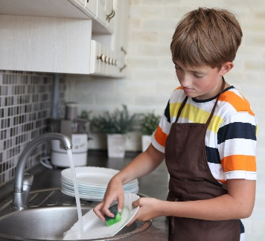 | Wash and rinse the plates

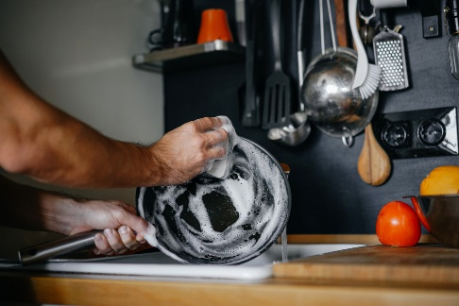 | Wash and rinse the saucepans

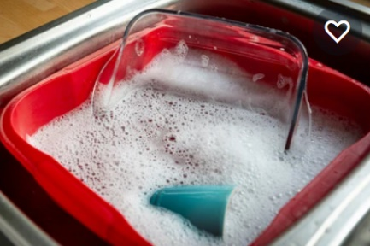 | Wash and rinse the baking trays

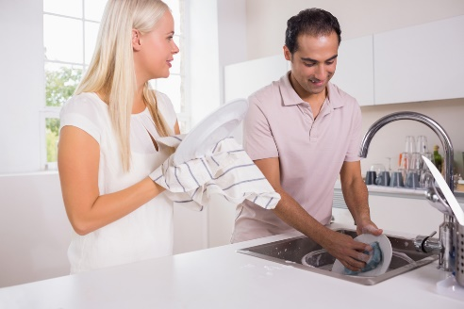 | Dry up using a clean tea towel

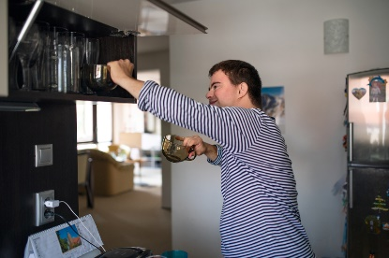 | Put everything away

